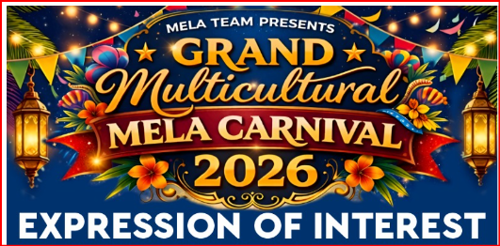

Sponsorship Expression of Interest Form
📍 Svoboda Park, Kuraby, Brisb 📅 Saturday, 13 June ‘26

🏢 1. Business / Organisation Details
- Business / Organisation Name: ___________________________________________________________

- ABN (if applicable): __________________________________________

- Contact Person (Full Name): ___________________________________________________________

- Position / Title: ______________________________________________

📞 2. Contact Information
- Phone Number: _________________________________________

- Email Address: __________________________________________

- Website / Social Media (if applicable): __________________________________________________________

- Business Address: __________________________________________

🎯 3. Sponsorship Interest
Please indicate your preferred sponsorship level:
☐ Platinum Sponsor
☐ Gold Sponsor
☐ Silver Sponsor
☐ Bronze Sponsor
☐ Community Sponsor
☐ Custom Sponsorship Package (please specify):
_______________________________________________________________

💰 4. Sponsorship Contribution
- Proposed Sponsorship Amount (AUD): $__________________________

- Type of Contribution:
- ☐ Cash Sponsorship
☐ In-Kind (Products/Services)
☐ Combination
If In-Kind, please describe:__________________________________________

🎪 5. Sponsorship Benefits Preference
Please select areas of visibility/benefit you are interested in:
☐ Logo on event marketing materials
☐ Social media promotion
☐ Stage acknowledgement
☐ Stall / booth at event
☐ Banner display at venue
☐ Inclusion in media releases
☐ VIP invitation access
☐ Other: __________________________________________

📢 6. Branding Requirements
- Company Logo Provided: ☐ Yes ☐ No
- Preferred Branding Message / Tagline:

- Any specific requirements or expectations:

🤝 7. Agreement & Confirmation
I confirm my interest in sponsoring the Multicultural Mela Carnival 2026 and understand that final sponsorship benefits will be confirmed upon agreement with the organising committee.
Signature: __________________________
Name: ........................................................
Date: __________________________

📧 Submission Instructions
Please complete this form and email to:
📩 melacarnivalqld@gmail.com
For enquiries, contact:
📞 Raj 0402651045 Mehzabeen 0416522125
Fina 0412411055 Farzana 0401428248

🌍 About the Event
The Multicultural Mela Carnival is a not-for-profit community event celebrating diversity, culture, and unity through food, performances, and family-friendly entertainment. Your sponsorship supports community engagement and cultural inclusion across South East Queensland.

