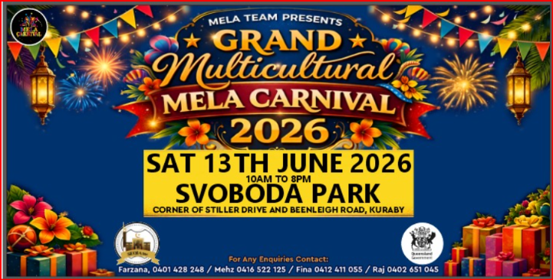

MULTICULTURAL MELA CARNIVAL 2026 Stall Application Form
Vendor Details:
1. Vendor Name: ________________________________________
2. Business Name (if applicable): __________________________
3. ABN Number ( if available) _____________________________
4. Contact Person: __________________________________________
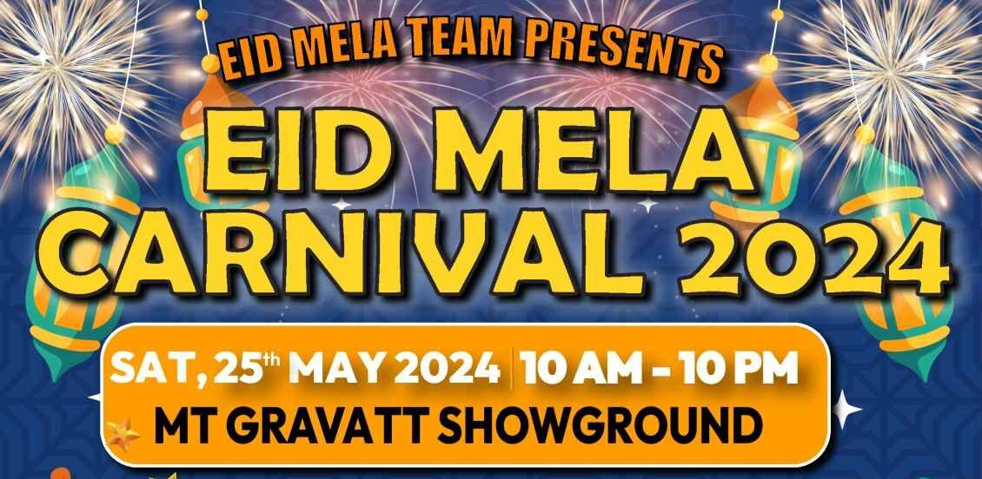
5. Phone Number: __________________________________________
6. Email Address: ___________________________________________
7. Address: __________________________________________________
Stall Information:
7. Stall Type (e.g., Food, Jewellery, Boutique): ________________________________
____________________________________________________________________
8. Description of Products/Services sold: _____________________________________
9. Stall Size if bringing own marquee: ________________________________________
Permissible size 3X3 m only for food stalls, 2.4m (frontage) X 2.4m for boutique stalls)
10. Number of Staff Attending: ___________________________
Stall Fee Payment Details:
11. Stall Fee Amount: _________________________________________
12. Payment Method (Bank Transfer): ___________________________
13. Payment Date: _________________ (Send screenshot) Sent : Yes No No
14. Transaction/Reference Number: ___________________________
Additional Information:
- Special Requirements/Requests: ___________________________

- Electricity Requirements (if any): No of 10Amp _________No of 15 Amp_________

- Health and Safety Compliance: [ ] Yes [ ] No (Please attach relevant documentation if applicable) ie. Food licence available, Public Liability Insurance Policy.

Terms and conditions:
By signing below, I acknowledge that I have read and agree to abide by the terms and conditions set forth by the event organizers. I understand that failure to comply may result in the cancellation of my stall application.
All meat/food supplied MUST be from halal source, certification/receipt will be sighted. You will only be selling what’s mentioned in your application form on the day.
Signature: ___________________________Date: ___________________________
Please submit this completed form and the stall fee payment to the event organizers by the specified deadline of the 7th of June 2025. For any inquiries or assistance, please contact.
• Mehz 0416522125 • Farzana 0401428248
• Fina 0412411055 • Raj Raaz 0402651045
Thank you for your interest in participating in our carnival event!
STALL PRICES
Food stall (3m x 3m - provide your own marquee) $350
Food truck mobile (Up to 6m long) $450
Boutique Stall Covered area $350
Beverage mobile kiosk (ONLY coffee, slushy, other drinks ) $300
Jewellery & Perfume stall $350
Exhibition stall Not-for-Profit $150 Businesses $250
Please contact Mehz or Fina or Farzana if you require further information regarding stalls.
Account details: Mela Carnival
BSB: 034279 ACCOUNT No : 834963
IMPORTANT: Please put your name/business name as the reference

